**DAILY ONLINE ACTIVITIES SUMMARY**

|  |  |  |  |  |  |  |  |  |
| --- | --- | --- | --- | --- | --- | --- | --- | --- |
| **Date:** | **19-05-2020** | | | | | **Name:** | **Raksha S** | |
| **Sem & Sec** | **6th B** | | | | | **USN:** | **4AL17CS073** | |
| **Online Test Summary** | | | | | | | | |
| **Subject** | | **Computer Graphics and Visualization(CGV)** | | | | | | |
| **Max. Marks** | | **60** | | **Score** | | | **56** | |
| **Certification Course Summary** | | | | | | | | |
| **Course** | **FullStack Webdevelopment and Cyber Security Specialisation:part1** | | | | | | | |
| **Certificate Provider** | | | **Great learning**  **udemy** | | **Duration** | | | **45days**  **30days** |
| **Coding Challenges** | | | | | | | | |
| 1. Problem Statement: 1.We have a Letter or a word then we need add some letters to it and need to find out shortest palindrome For example we take "S": S will be the shortest palindrome string. If we take "xyz": zyxyz will be the shortest palindrome string So we need to add some characters to the given string or character and find out what will be the shortest palindrome string by using simple java program. 2. Write a simple code to identify given linked list is palindrome or not by using stack. First take a Stack. Traverse through each node of the linked list and push each node value to Stack. Once the traversal & copying is done, iterate through linked list from head node again. In each iteration, pop one stack element and compare with node value in respective iteration. It is expected to match stack popped value with node value. In case of all matches, its a palindrome. Any one element mismatch makes it not a palindrome. | | | | | | | | |
| Status: YES, Completed all Programs | | | | | | | | |
| **Uploaded the report in Github** | | | | | **YES** | | | |
| **If yes Repository name** | | | | | **Daily-status** | | | |
| **Uploaded the report in slack** | | | | | **YES** | | | |

Online Test Details: (Attach the snapshot and briefly write the report for the same)

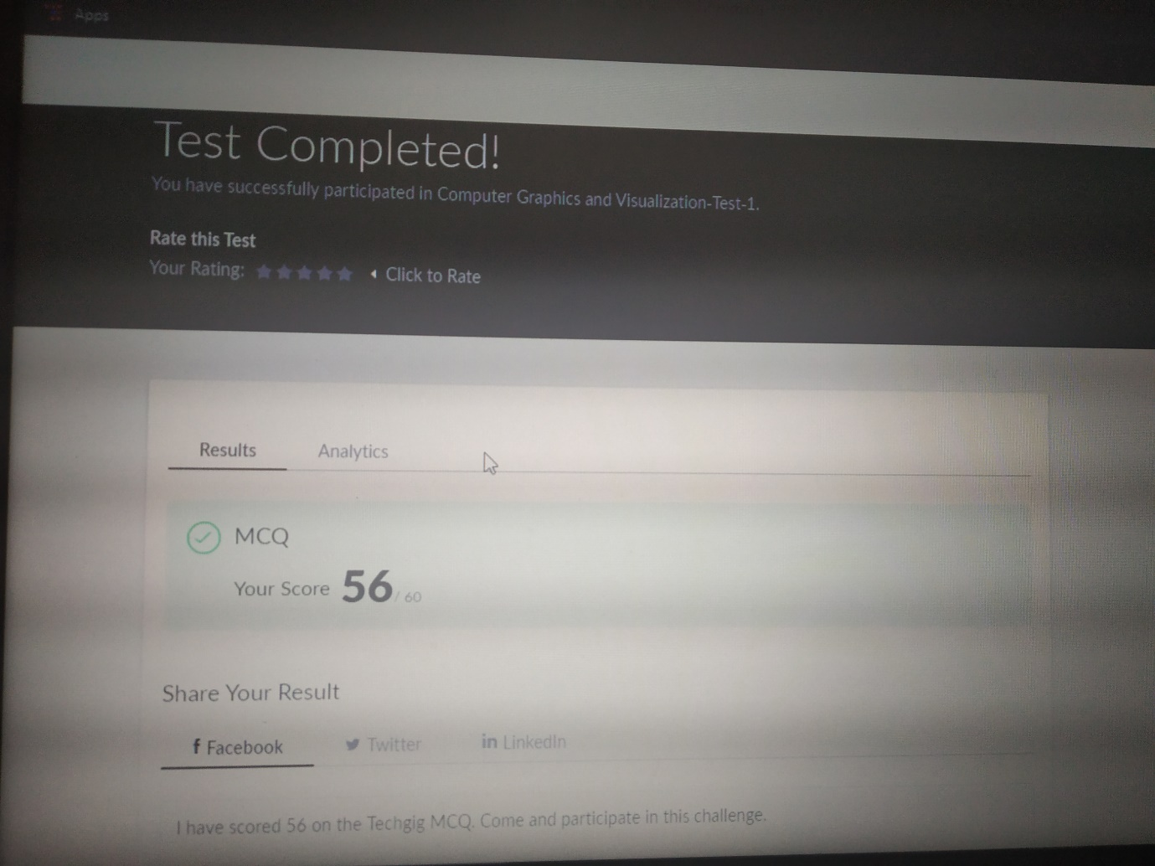

Certification Course Details: (Attach the snapshot and briefly write the report for the same)

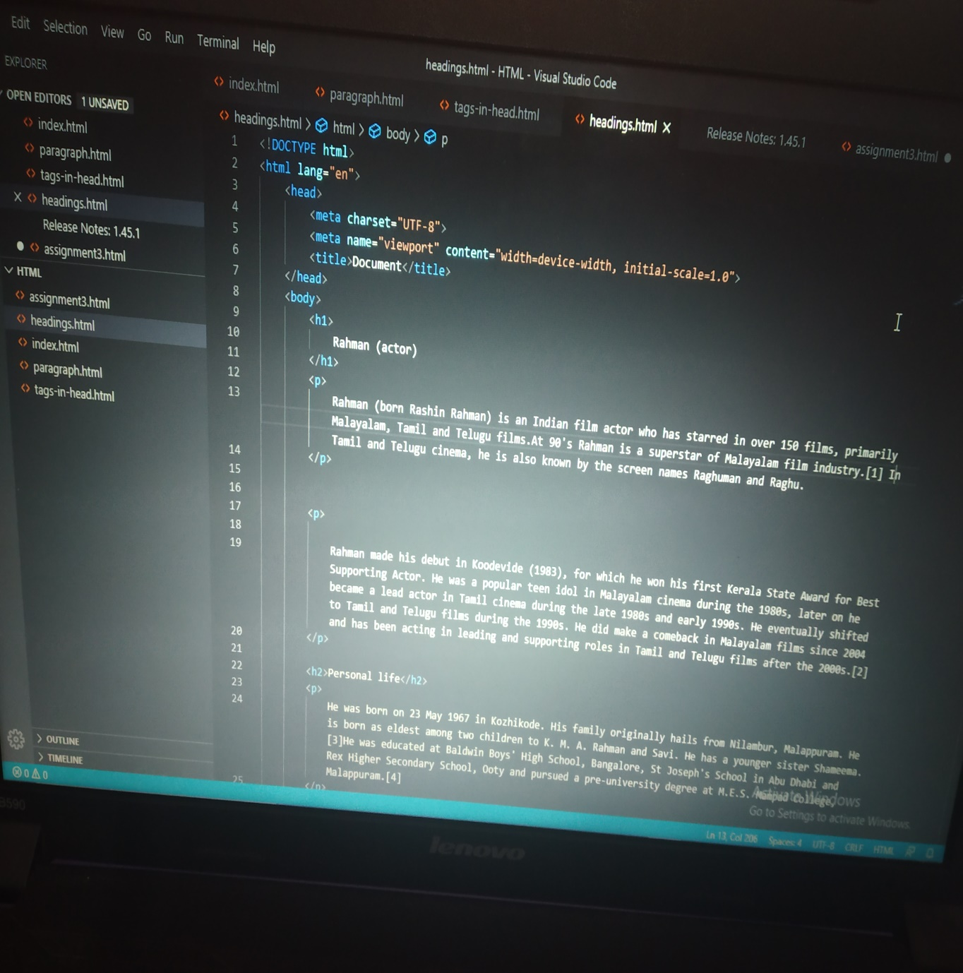

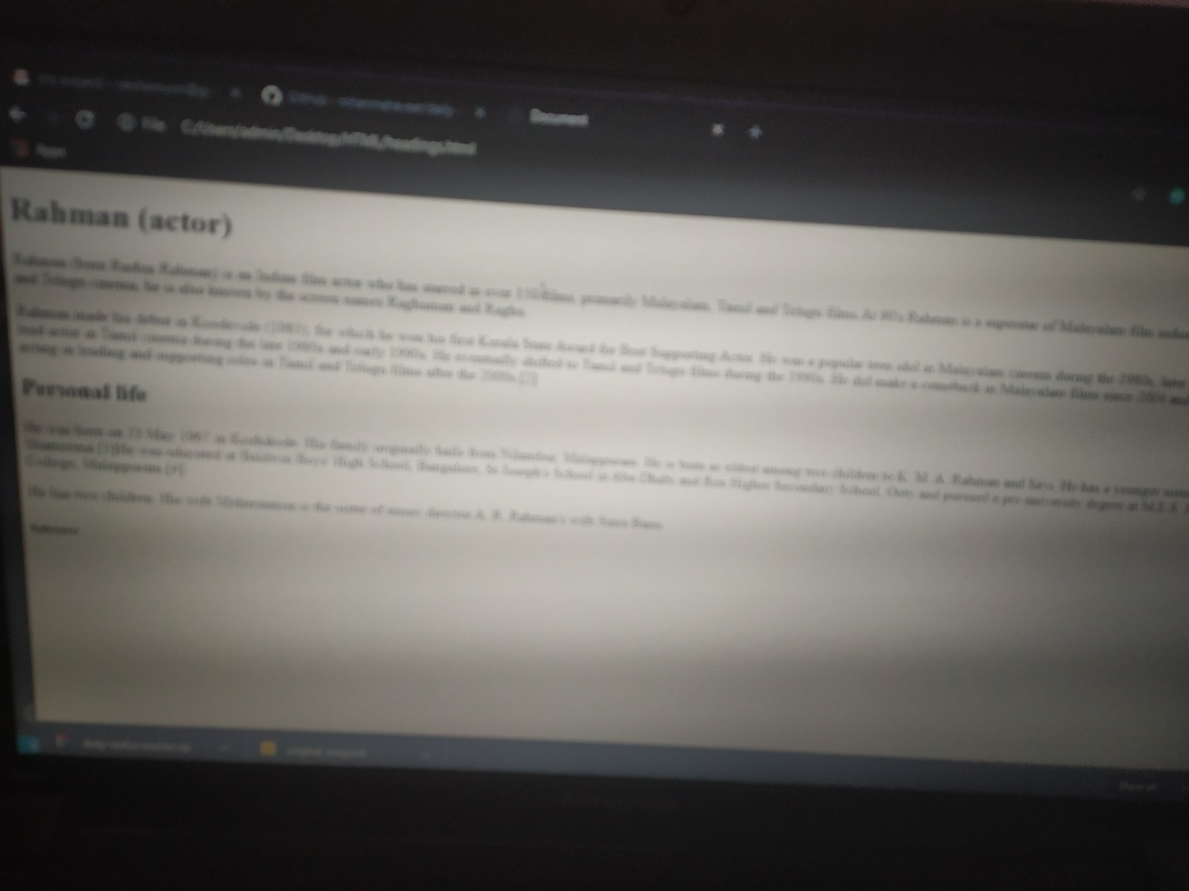

The above course is taken up by me on fullstack webdevelopment where I am learning first frontend using html file,html structure using html tags and css.Today I learnt to create my webpage on actor rehman and learnt all h1 to h6 header tags and its importance and paragraph tags.

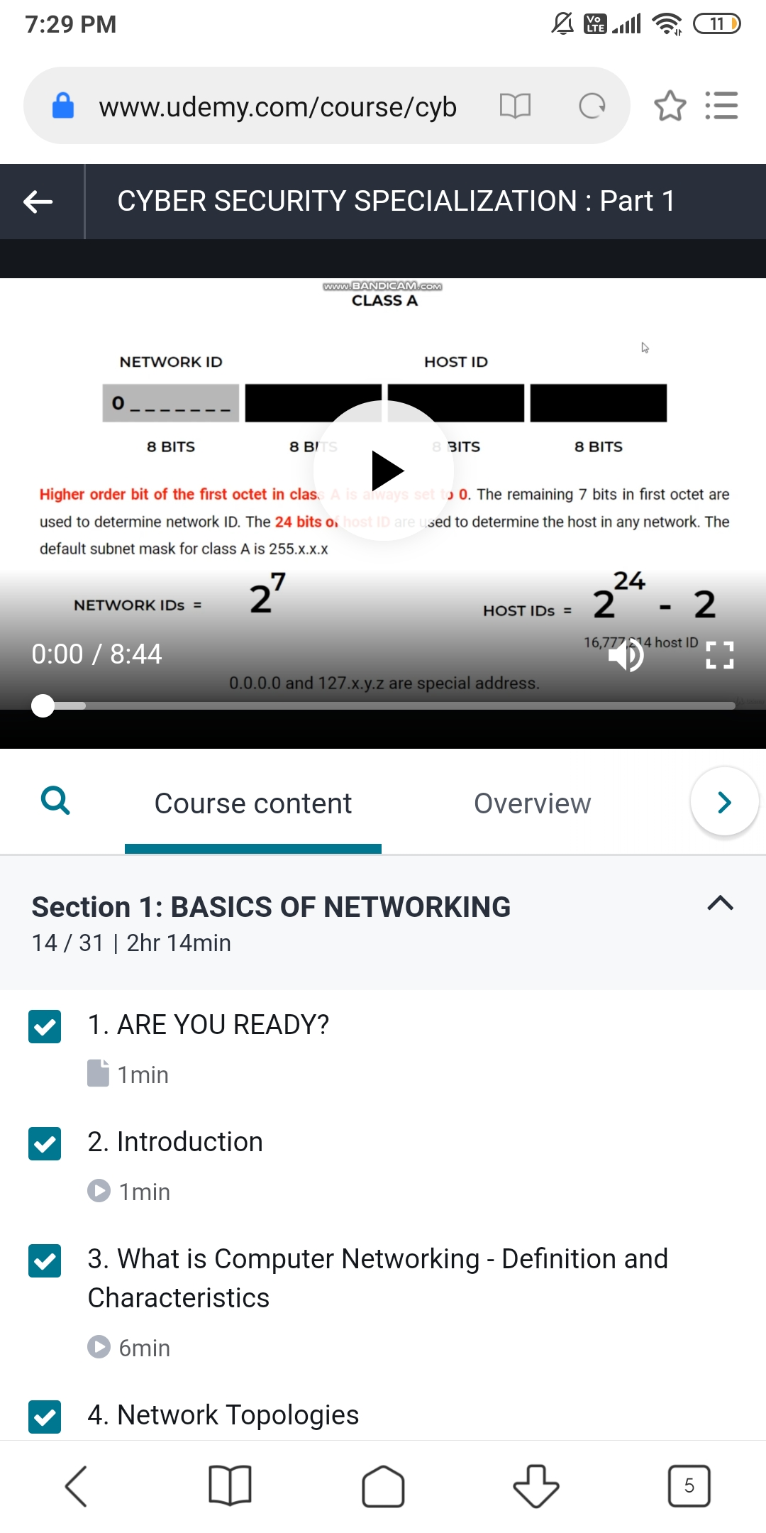

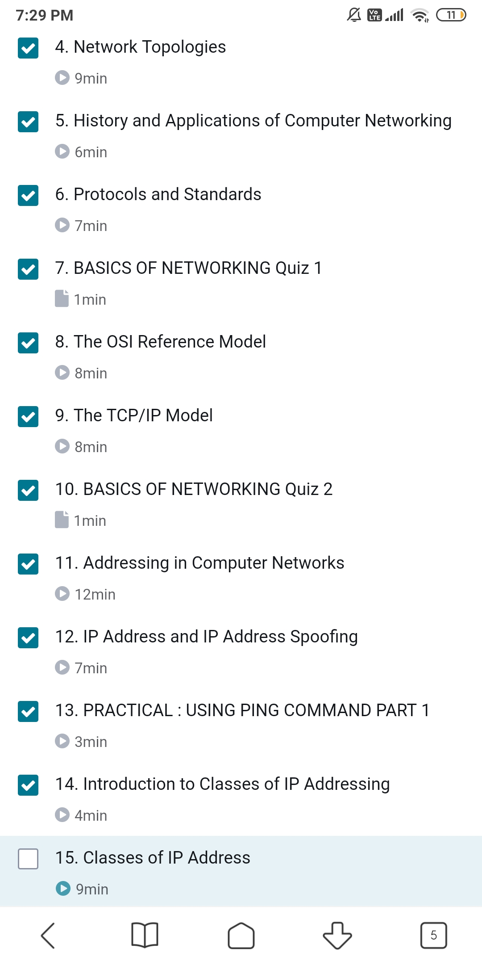

The above course is choosen by me on Cyber Security Specialisation:part1 where I studied about networks and internet first. I learnt about topologies and different protocols and its uses and learnt about OSI and TCP/IP model its uses and applications and drawbacks.

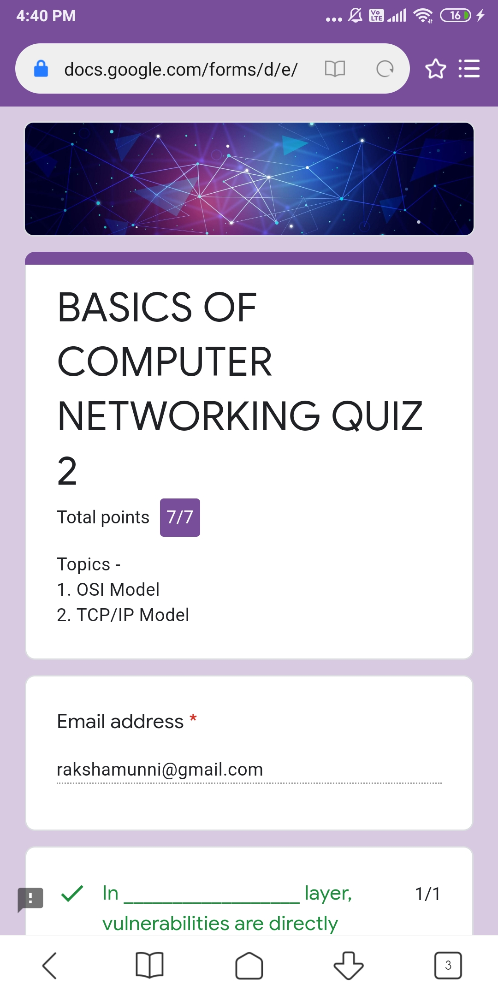

Coding Challenges Details: (Attach the snapshot and briefly write the report for the same)

